eSciDoc Highlights

eSciDoc assists organizations in establishing integrated information infrastructures. As a consistent technology platform, eSciDoc covers all aspects of your information lifecycle management. Its building block structure is flexible enough for your specific needs.

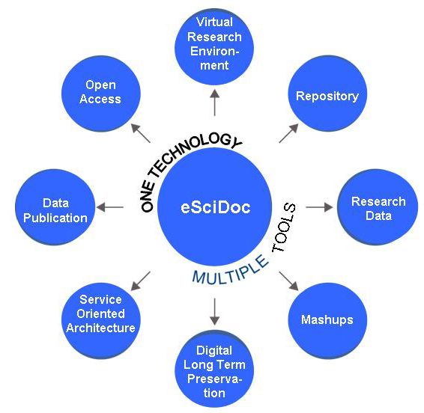

eSciDoc stands for:
- Data continuum: One environment for research data and publications
- Data security: Fine-grained access control throughout the research process
- Flexibility and customization: Generic services for re-use across disciplinary and institutional boundaries
- Sustainability: Organizational commitment and professional support
The Fedora Commons community considers eSciDoc one of the flagship projects in eResearch.
eSciDoc Community and Support
contact@escidoc.org
www.escidoc.org/support
Do you need more information or support for using eSciDoc?
We welcome feedback and encourage you to provide us with your usage scenarios, share your expertise with us, and create your own applications.

eSciDoc Funders

eSciDoc started as joint project of the
Max Planck Society and FIZ Karlsruhe to establish an eResearch environment for multi-disciplinary research. Both partners have officially committed themselves to continuing their cooperation to ensure the sustainability of eSciDoc.

Max Planck Digital Library (MPDL)
www.mpdl.mpg.de
The MPDL is a scientific service unit within the Max Planck Society (MPS). It provides services which help researchers of the MPS manage their scientific information workflow.

FIZ Karlsruhe – Leibniz Institute for Information Infrastructure
www.fiz-karlsruhe.de
FIZ Karlsruhe is an international service partner for science and research. It offers KnowEsis, the professional consulting and support services for eSciDoc, including training, customized development, and operation of entire applications.

Last update: September 2010

enabling eResearch

www.escidoc.org
What is eSciDoc?

eSciDoc is an eResearch environment developed specifically for the global and interdisciplinary collaboration of scientific communities. It comprises a generic, discipline-independent infrastructure and customized applications that enable innovative eResearch scenarios. Scientists, librarians, and software developers can work with research data, create novel forms of publications, and establish new ways of scientific collaboration.

eSciDoc is intended to ensure open and persistent access to research results and materials of scientific institutions and research organizations like the Max Planck Society.

BILD: WORD CLOUD zu Disziplinen

Vorschlag - Aussage als Bildunterschrift: Disciplines that already work with eSciDoc

eSciDoc is Open Source

The eSciDoc software is licensed under the Common Development and Distribution License, an OSI-approved open source license. Everyone is invited to download and evaluate the eSciDoc Infrastructure and the eSciDoc Applications. Re-using the eSciDoc software will strengthen the platform and help to create synergies.

eSciDoc Applications

eSciDoc Applications address specific eResearch scenarios based on the requirements of individual research communities. The results are innovative tools for scientific collaboration and data management.

eResearch Environments
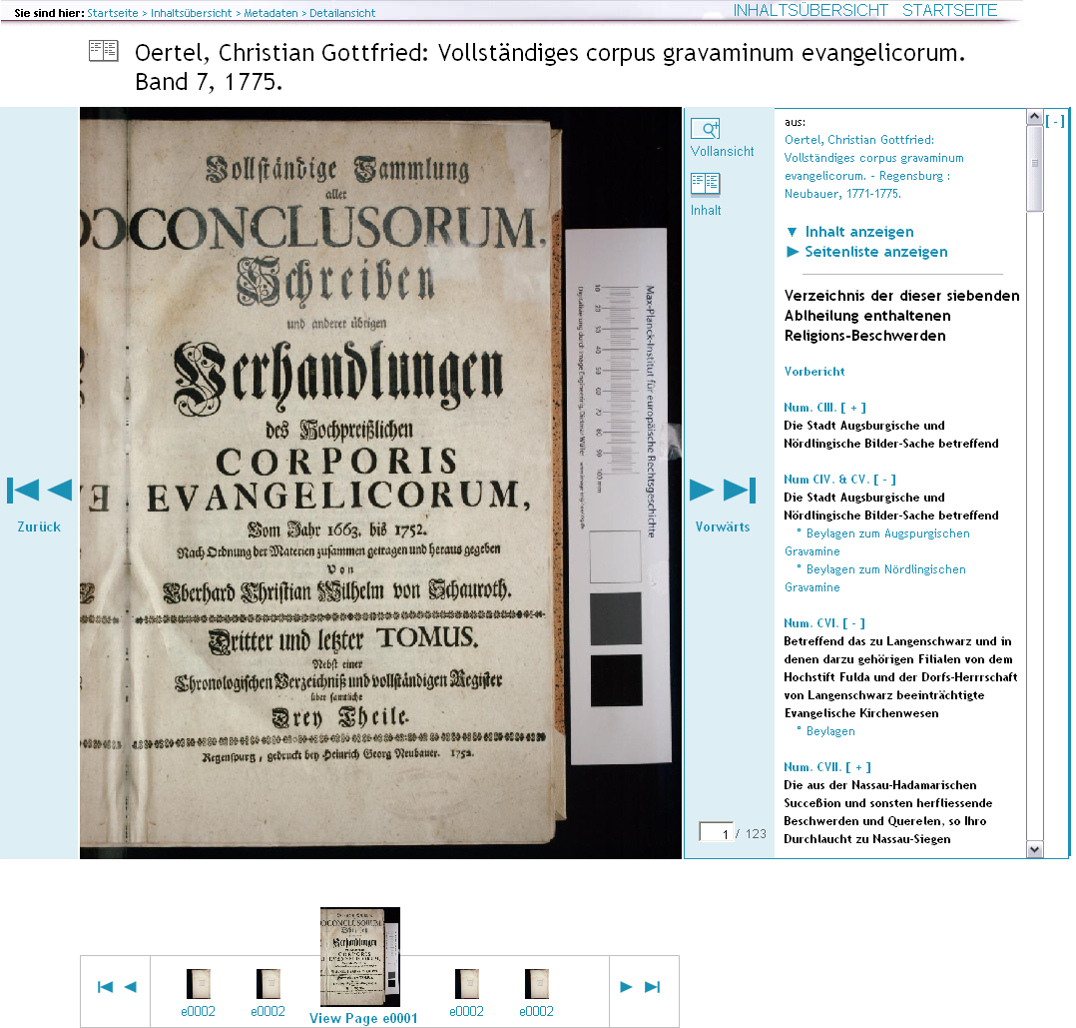
Virtueller Raum Reichsrecht (ViRR): Digital collection and cooperative working environment for legal text corpora
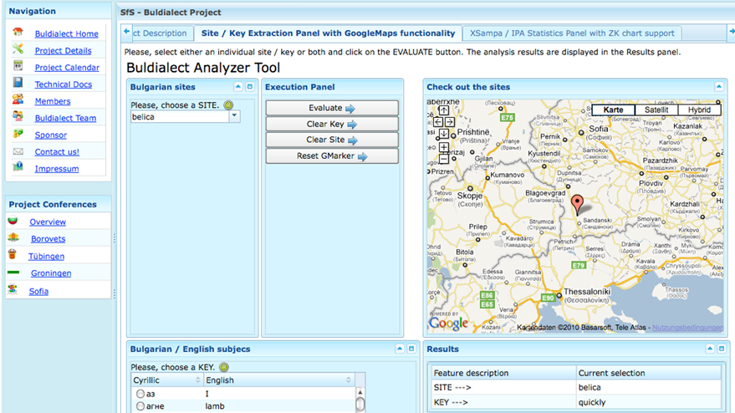
BW eSci(T): Collaborative eScience environment with contextualized data management and customized tools

Publication Data Management
PubMan: An institutional repository for managing, disseminating, and re-using publications and supplementary material.

Research Data Management
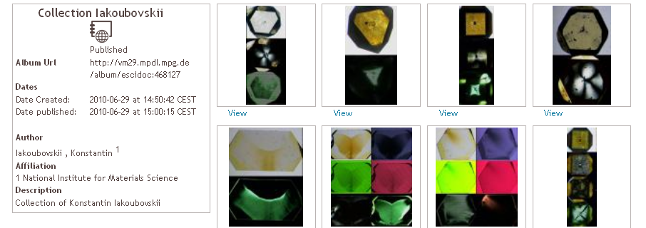

Diamonds and FACES: Two different digital collections of research data (image)
TEI Demonstrator: Collection of TEI (Text Encoding Initiative) documents

eSciDoc Infrastructure

The eSciDoc Infrastructure offers a scalable data management system with generalized services. The service-oriented architecture provides maximum flexibility when building customized applications that may range from lightweight tools to complex applications: Just use the services you really need.

The eSciDoc Infrastructure encapsulates the repository Fedora Commons and implements a broad range of commonly used data management services like
- Storage, update and versioning of any kind of resources
- Support of different objects, meta data profiles, aggregations and content models
- Long-term preservation aspects, including meta data generation (PREMIS)
- Security through distributed user authentication and authorization (Shibboleth)

