This tutorial demonstrates a full submission selenium testcase(in HTML) on http://qa-pubman.mpdl.mpg.de:8080/
TestCase:
Tester follows following steps: (PMTS-49 full_Submission_paper_submit)
- do full submission
- save item
- go to my items
- open previously created item
- edit item
- add MD, one file and one locator
- submit item

Step One:
Record testcase using Selenium IDE:
- Open Firefox, choose Selenium IDE from the Tools drop-down menu. Go to http://qa-pubman.mpdl.mpg.de:8080/pubman/ .

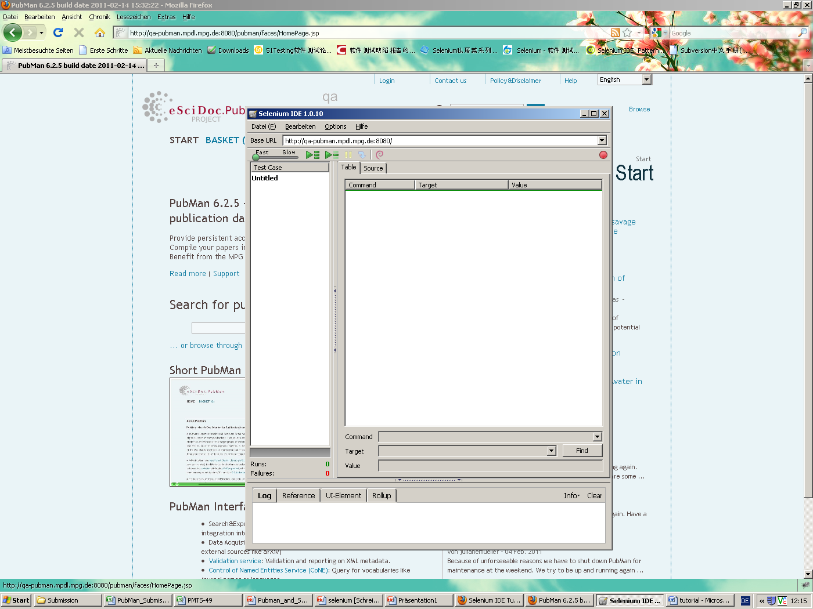

- Click the red record button starting record.
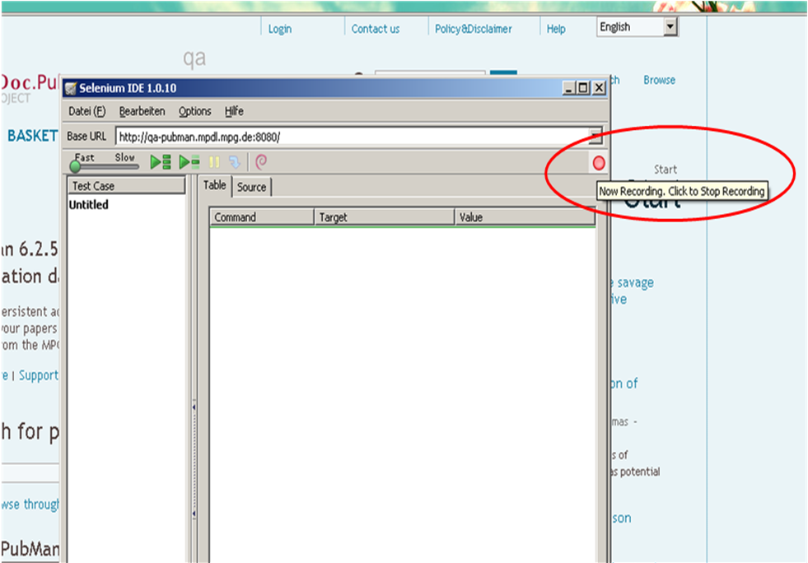

- Log in eSciDoc..
- Change to English mode:

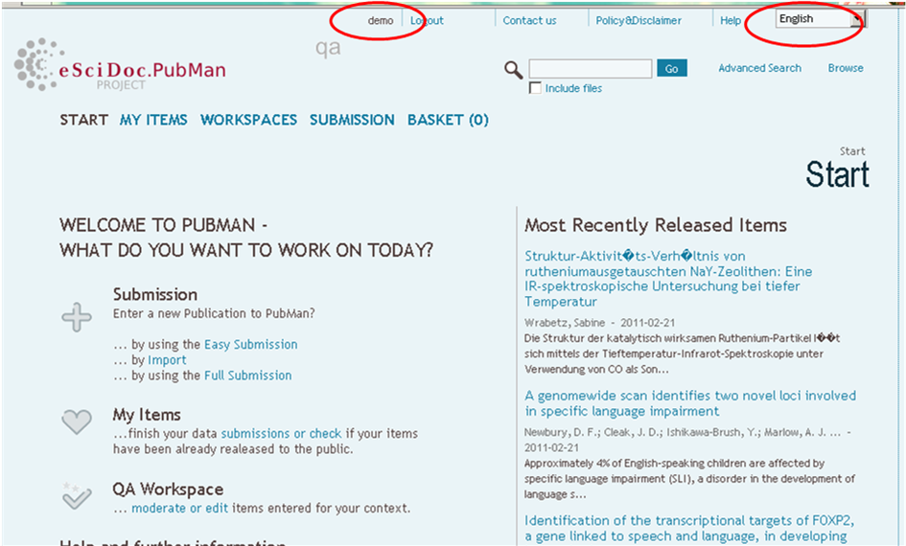

- Whole steps are recorded in IDE.
- Select full submission and choose the context “MPI for Psycholinguistics”

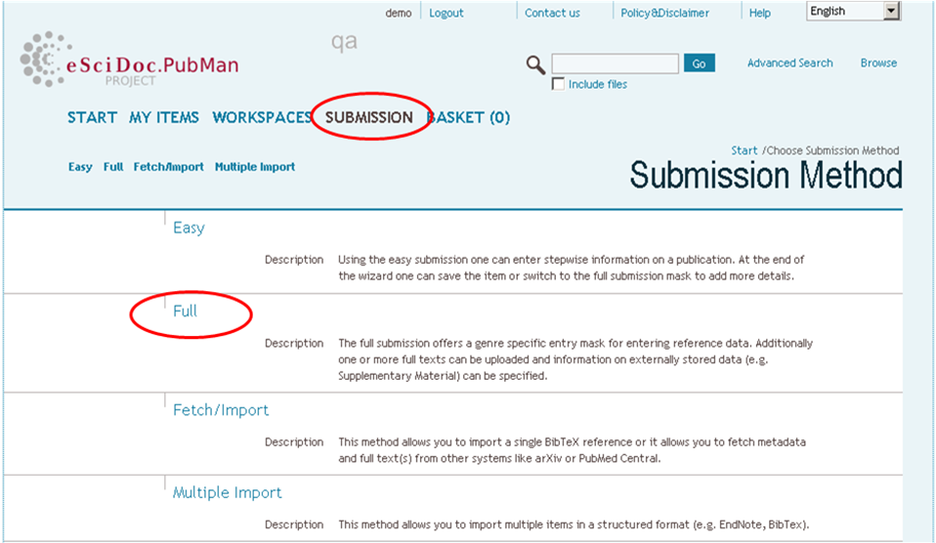

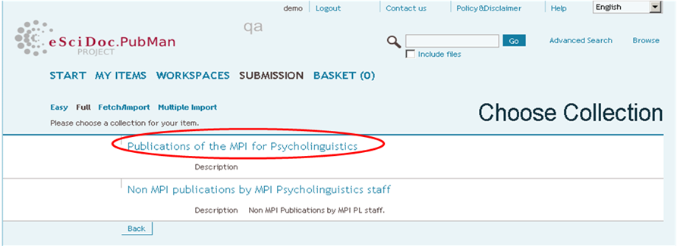
- Select Genre “Paper”, enter title “full submission paper”

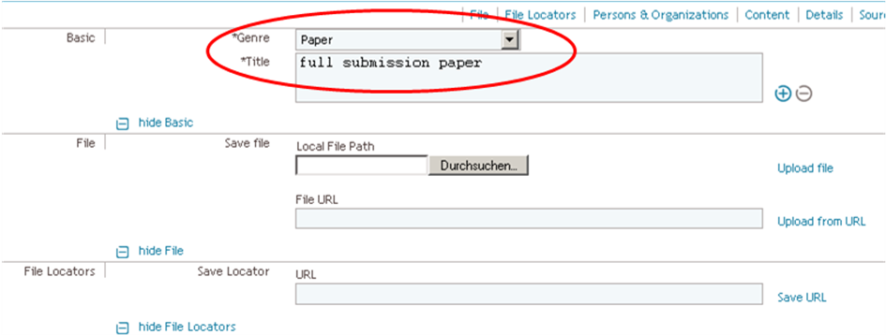

- Choose “editor” as creator role, select an author from auto-suggest person list.
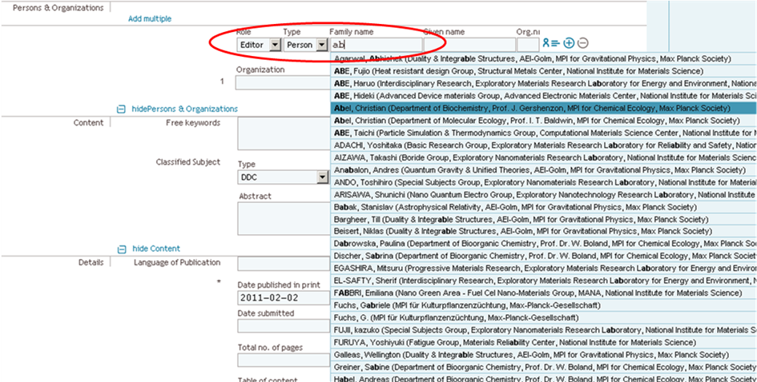
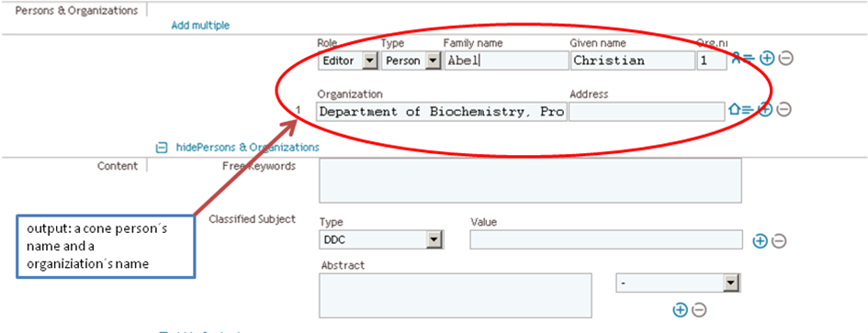

- enter “Date published in print” “2011-02-02”, save item.
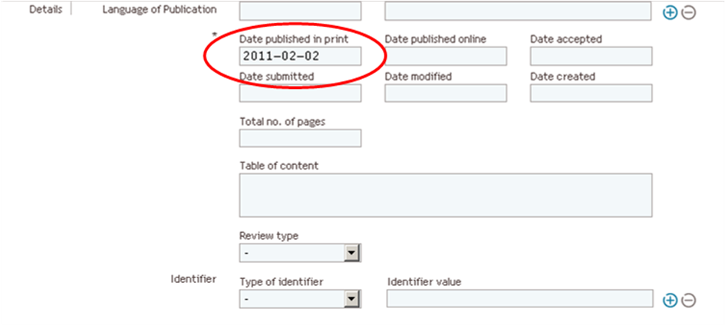
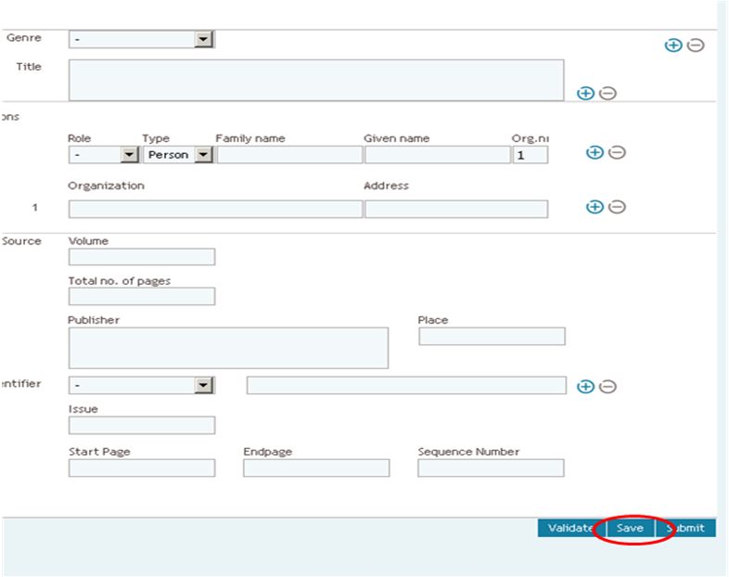
- go to my items, open the previously created item "full submission paper ", edit it
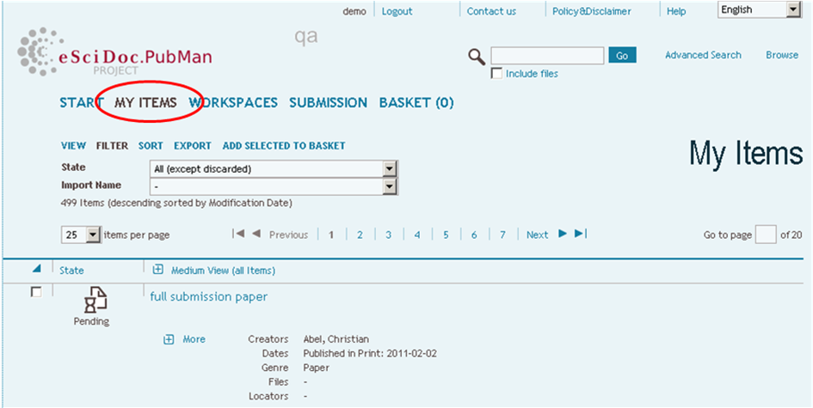
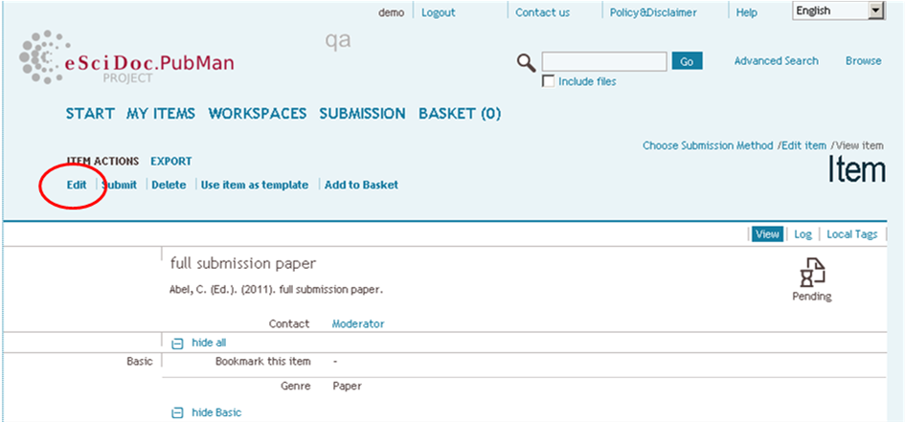
- upload a file and add a file locator, select “any fulltext” for both.
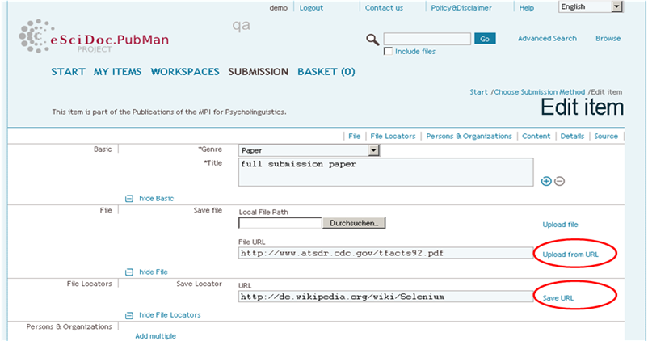
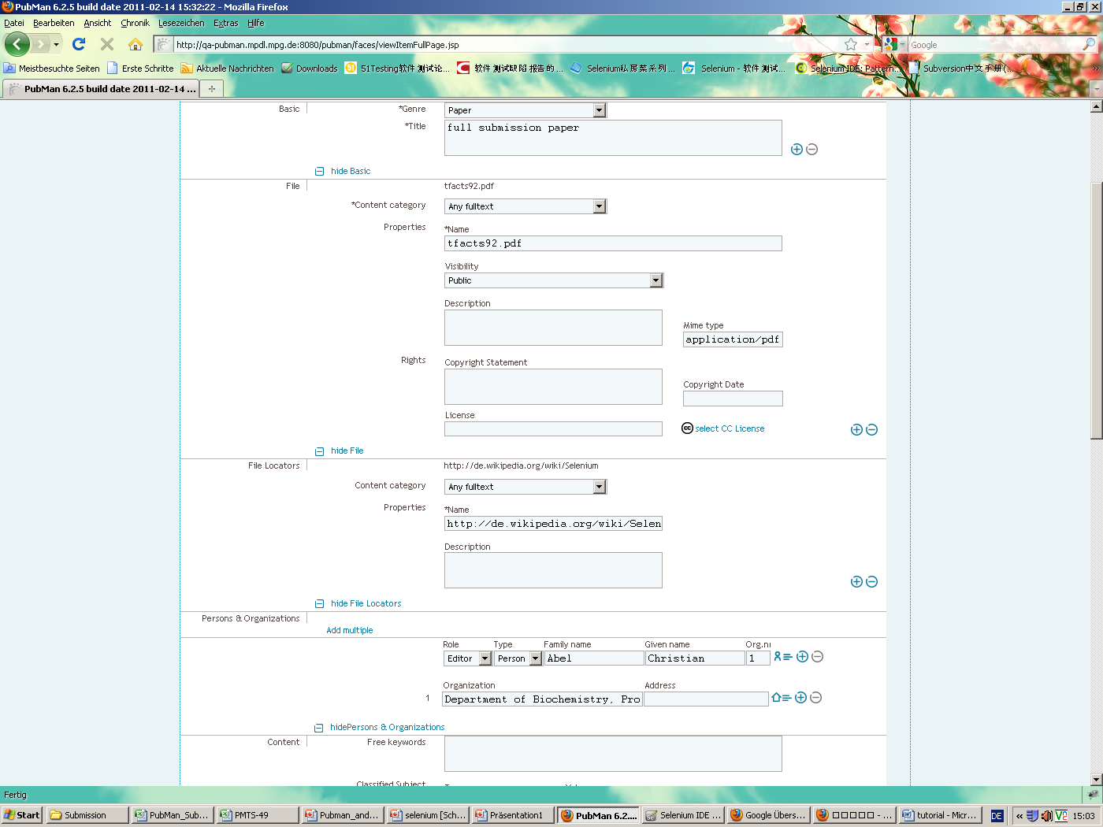

- Save the item again and submit it.
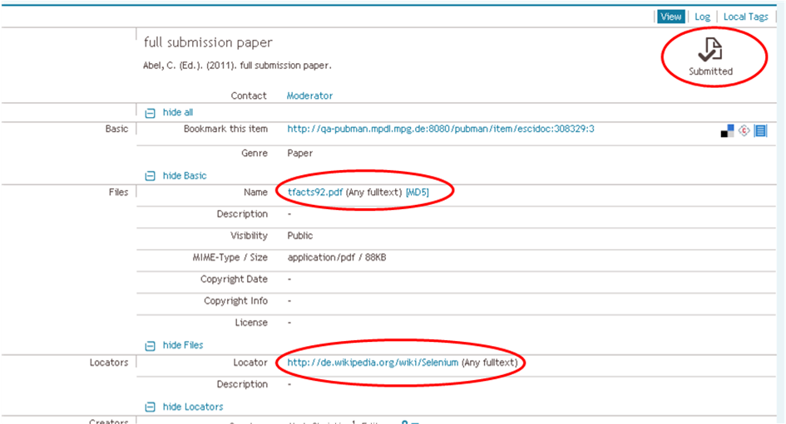

- Click the Record icon to stop recording in Selenium IDE. The recorded test in Selenium IDE like below:

- You can control test speed.
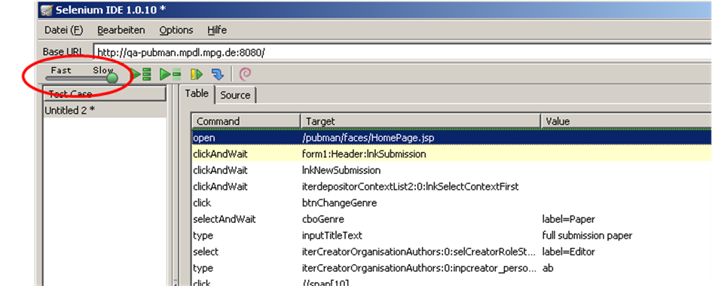

- Click green play button for playing back the recorded test scripts (make sure that you are logged out of qa-pubman.
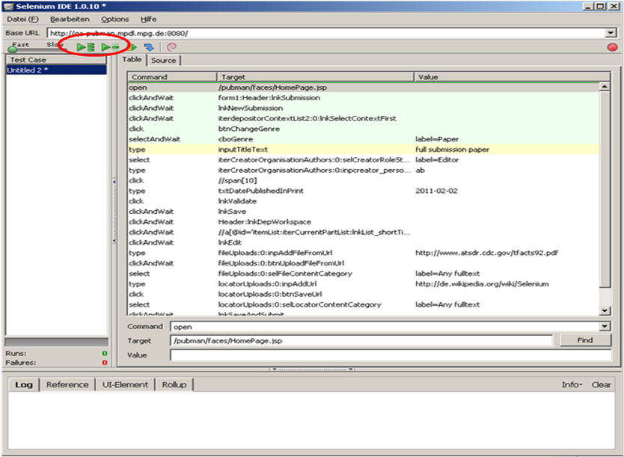

- Make the required changes to the Test Case:
- Change ‘”type” to “mouseDown” and “keyPress” commands for activating auto-suggest cone person list: Because the Auto Suggest List is not activated with the command ‘type’.
- Change “click” to “mouseOver” then “click” commands, in order to simulate a hovering action first. Use Xpath ‘//ul[3]/li[5]’ as target.
- Add the “waitForElementPresent” command for Ajax testing.
- Change the target of the command “clickAndWait”: use //a[@title='full submission paper'] instead of the target //a[@id='itemList:iterCurrentPartList:lnkList_shortTitle']/b
- Start the test again, it runs successfully.
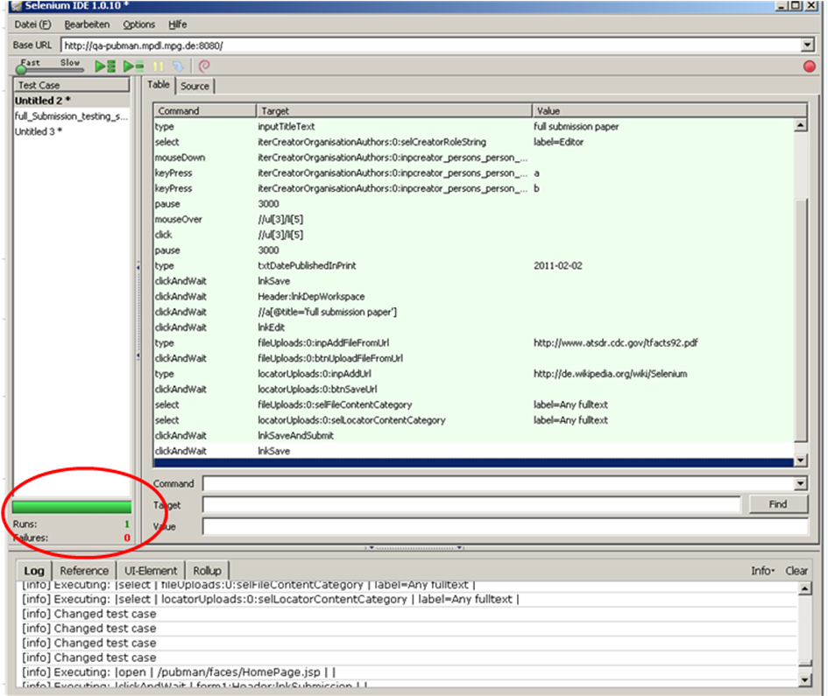
- The test case can be exported in other different languages.

