**(4-aussen)Research Benefits**

Oder anderer Punkt? Falls nicht: Auswahl!

* Improved visibility of research results
* Maintenance of both data and publications
* Security - Mixture of open access and private material
* fine-granular access rights
* Stability of references and citations
* Integration with existing tools
* Re-use of data
* Accountability of research
* Collaboration across institutional bounds
* distributed authentication
* tools for virtual working groups

**Support**

An introduction to eSciDoc through an extensive user guide and tutorials is available at: <http://www.escidoc.org/JSPWiki/en/Support>

The Max Planck Digital Library (MPDL) is a scientific service unit within the Max Planck Society (MPS). The MPDL provides services which help researchers of the MPS manage their scientific information workflow.

*Max Planck Digital Library*

Department Research & Development

[*service@mpdl.mpg.de*](mailto:service@mpdl.mpg.de)

FIZ Karlsruhe (FIZ) is an international service partner for science and research. FIZ offers under the name of KnowEsis professional consulting and support services for the eSciDoc Infrastructure and the Fedora Repository, including training, workshops, on-site support, and development of customized solutions.

*FIZ Karlsruhe*

*KnowEsis Consulting and Support Services*

[*knowesis@fiz-karlsruhe.de*](mailto:knowesis@fiz-karlsruhe.de)

**(Rückseite) eSciDoc Community**

eSciDoc started as joint project of FIZ Karlsruhe and the Max Planck Society (MPS) to establish a state-of-the-art eResearch environment for multi-disciplinary research.

Both partners have officially committed to continue their cooperation to **ensure the sustainability of eSciDoc** and to support the transformation of eSciDoc into a community-driven effort in the spirit of a true open source project.

The eSciDoc software is licensed under the **Common Development and Distribution License**, an OSI-approved open source license. Everyone is invited to download and evaluate the eSciDoc Infrastructure and eSciDoc Applications. Re-use of the eSciDoc software strengthens the platform and helps create synergies.

We welcome feedback and encourage users to provide us with their use cases and scenarios, share their expertise with us, and create their own applications.

**Contact**

MPDL

*Malte Dreyer (Research & Development)*

[dreyer@mpdl.mpg.de](mailto:dreyer@mpdl.mpg.de)

+49–(0)89 38602-225

FIZ Karlsruhe

*Matthias Razum (ePublishing and eScience)*

[Matthias.Razum@fiz-karlsruhe.de](mailto:Matthias.Razum@fiz-karlsruhe.de)

+49-(0)7247 808-457

Latest update: September 2010

**(Vorderseite)**

|  |  |
| --- | --- |
| http://colab.mpdl.mpg.de/mediawiki/skins/monobook/mpdl-logo.gif | FIZ-Karlsruhe-en[1] |



enabling eResearch

Stand: 7/26/2010 4:21:46 PM; Ute Rusnak

*The Open Source eResearch Environment*

**(1-innen) What is eSciDoc?**

eSciDoc is an **eResearch environment** developed specifically for the global and interdisciplinary collaboration of scientific communities. It comprises **a generic, discipline-independent infrastructure and customized applications** that enable innovative eScience scenarios. Scientists, librarians, and software developers can work with research data, create novel forms of publications, and establish new ways of scientific collaboration.

eSciDoc is intended to ensure open and persistent access to research results and materials of scientific institutions and research organizations like the Max Planck Society.

??? Evtl. BILD mit WordCloud zu Multidisziplinärem Chrakter ???

**(2-innen)The eSciDoc Infrastructure**

The eSciDoc Infrastructure provides a **scalable data management system with generalized services**. The Service-oriented architecture provides maximum flexibility when building customized applications that may range from lightweight tools to complex applications: **Just use the services you really need.**

The eSciDoc Infrastructure encapsulates the repository Fedora Commons and implements a broad range of commonly used data management services. Just to name a few: BILD statt Aufzählung möglich???

* Storing, updateing and versioning of any kind of resources
* Support of different objects, meta data profiles, aggregations and content models
* **Long-term preservation aspects**, including meta data generation (PREMIS)
* [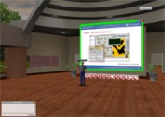](http://www.hdm-stuttgart.de/view_news_zoom?bild=zoom_Wonderland3_meldung.jpg&ident=news20091027130126&titel=Der+Weg+in+das+Labor+der+Zukunft)Assigning **persistent identifiers**
* Harvesting **meta data** conformant with the OAI-PMH standard and automatic extraction of technical meta data
* *Generic search and indexing engine for all kind of data*
* **Security** with distributed user authentication and authorization (Shibboleth)
* Event logging and statistics
* Internationalization and Localization

The eSciDoc Infrastructure is "**enabling technology**": Scientists can focus on domain-specific application logic when building new applications.

**(3-innen)The eSciDoc Applications**

Current eSciDoc Applications address **specific eResearch scenarios** based on the requirements of individual research communities. The results are innovative tools for scientific collaboration and research data management.

***eResearch Environments***

**BW-eSci(T):** Prototypical eResearch environment which supports long-term preservation of all kinds of research data as well as fine-grained and contextualized data management.

**ViRR:** Digital collection and cooperative working environment for various legal text corpora.

**Research Data Management**

**BW-eLabs:** Access point to diverse remote and virtual experimental resources in combination with scientific data management

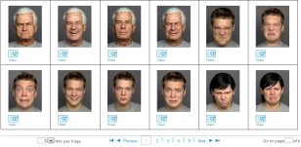**FACES:** A digital collection of pictures with face stimuli requiring detailed access rights

**Publication Data Management**

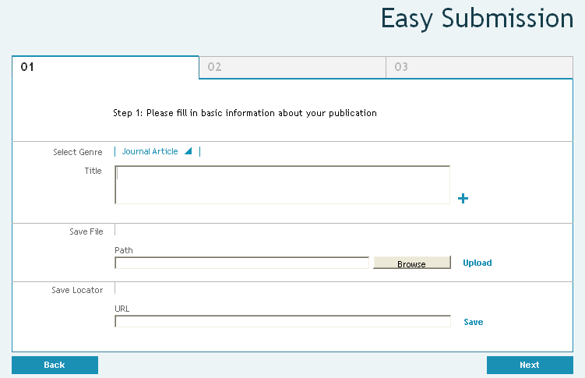**PubMan:** An institutional repository with open access features, allowing for publication data management and easy linking of research data.